**DISCLAIMER**

The *preliminary Spec Tests* that you are able to run only test that your code compiles and provides an indication about how well your code can be tested with the *complete Spec Test*. The *preliminary Spec Tests* **DO NOT TEST** the correct functioning of your code.  
The maximum score you can obtain with the *preliminary Spec Test* is 10 / 100. If you obtain this maximum score it indicates that your code is likely compatible with the *complete Spec Test*.  
**It is your responsibility to test that your code is correct.**

After the deadline, your code will be tested with the *complete Spec Test* which does test the correct functioning of your code.  
The maximum score you can obtain with the *complete Spec Test* is 100 / 100.  
**The *complete Spec Test* will determine your grade for this assignment.**

# General problem description

You will write C++ code to solve an interesting dynamics problem. Walking robots have gained interest in recent years. While you can find complex and sophisticated walking robots online, today, you will consider the so-called **simplest walker**, as described by Garcia et al. in <https://doi.org/10.1115/1.2798313> (available as [PDF](https://weblab.tudelft.nl/getFile/81550/SimplestWalker.pdf)).

The simplest walker has two rigid massless legs that are hinged at the hip, and point-masses at the feet. The mass of these feet is negligible compared to a point mass at the hip. It walks down a slope with constant inclination γ. We assume that the stance leg does not slip nor rebound, such that the foot-ground contact may be modeled as a hinge joint as well. The definition of the stance leg angle φ and swing leg angle θ are shown in the figure below

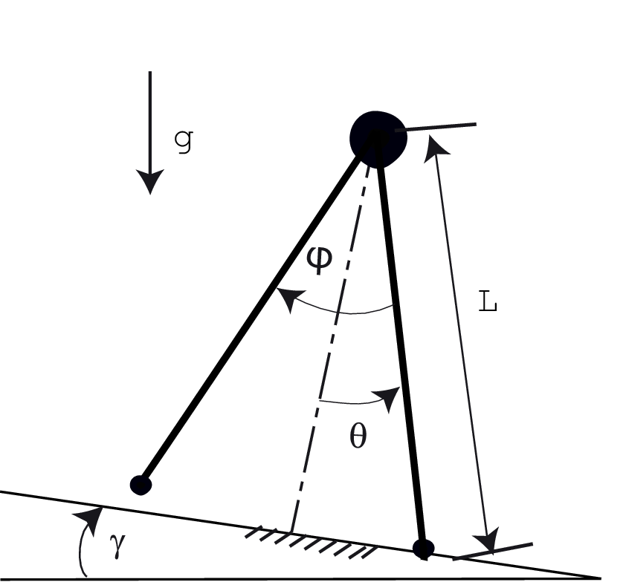

Given are simplified second-order differential equations of motion of the simplest walker when it is supported on one leg (which is called single support), in the generalised coordinates θ and φ:

